**THE TABLEAU HR SCORECARD: MEASURING SUCCESS IN TALENT MANAGEMENT**

**1 INTRODUCTION:**

1.1 Overview:

The HR Scorecard is a strategic HR measurement system that helps to measure, manage and improve the strategic role of the HR department.

Most Innovative organization in the sector

Employees branding efforts should focus on type of worker. Aligning HR System

A balanced scorecard is a strategic management performance metric that helps companies identify and improve their internal operations to help their external outcomes

1.2 Purpose:

Hire more qualified professional. The balanced scorecard is a management system aimed at translating an organizations strategic goals into a set of organizational performance objectives that ,in turn, are measured ,monitored and changed if necessary to ensure that an organizations strategic goals are met .

Grow value with specific use cases. Cultivating a learning culture

Mastering the Art of succession Planning. One of the best ways to present your HR metrics is to use visual aids, such as charts, graphs, tables, and dashboards.

2 PROBLEM DEFINITION & DESIGN THINKING:

2.1 EMPATHY MAP:

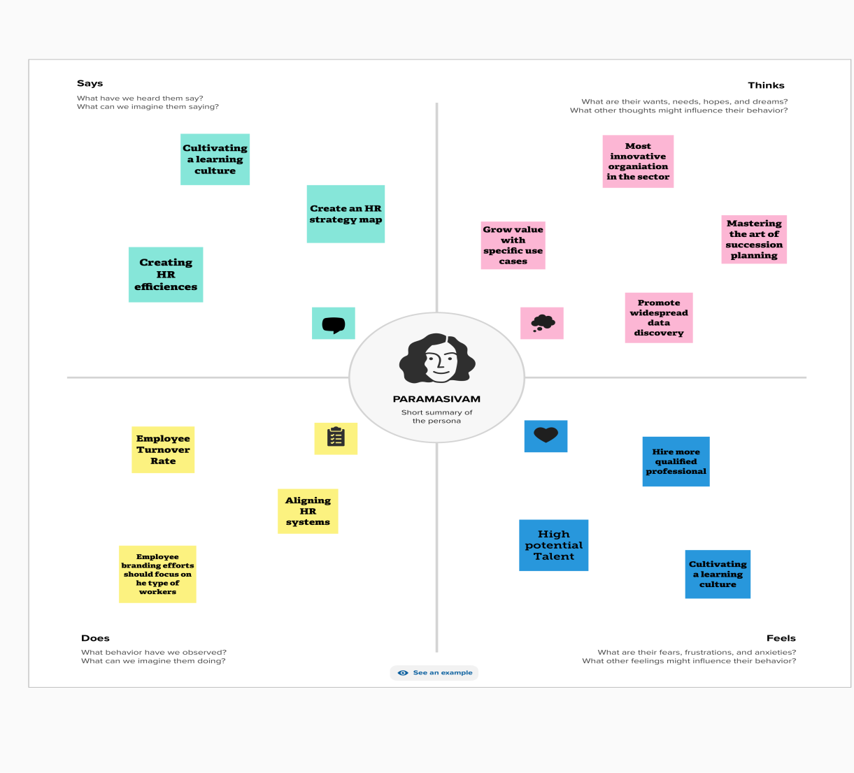

Page break

----------------------------------------------------------------------------

2.2 IDEATION AND BRAINSTORMING MAP:

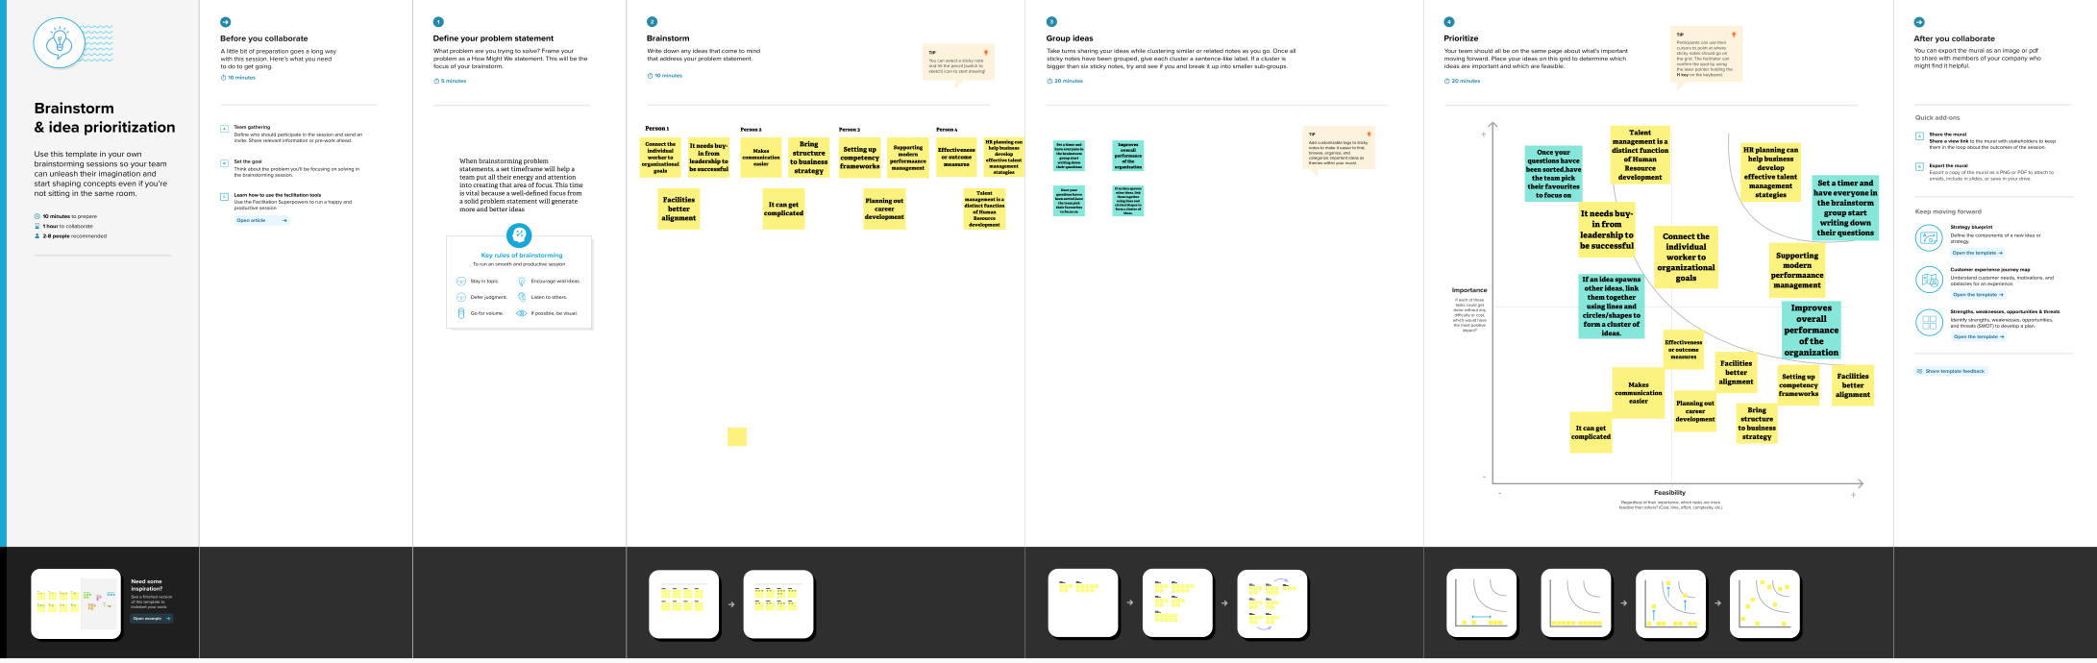

3 Result :

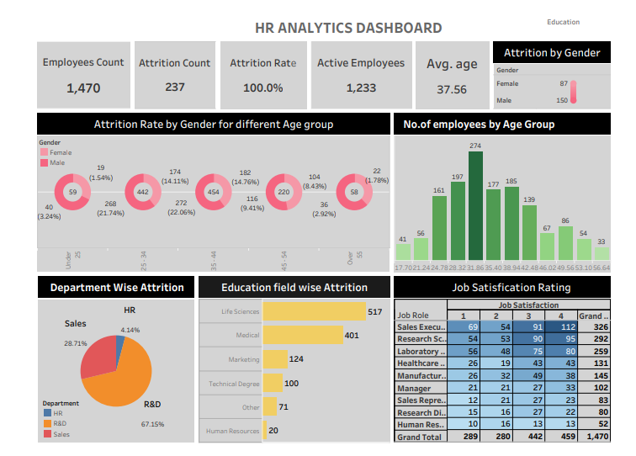

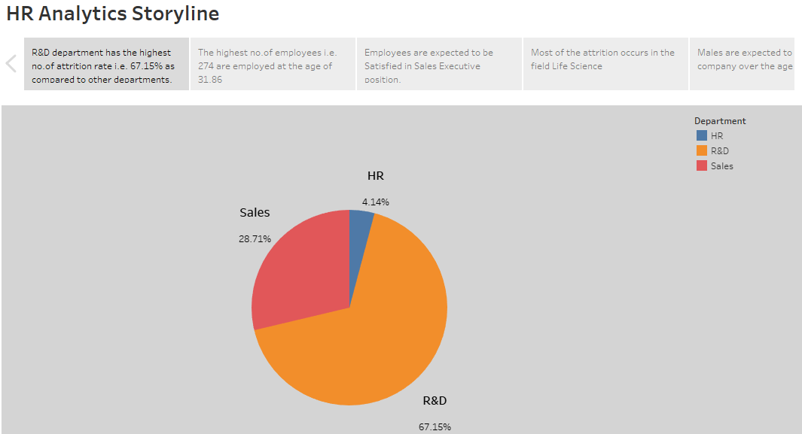

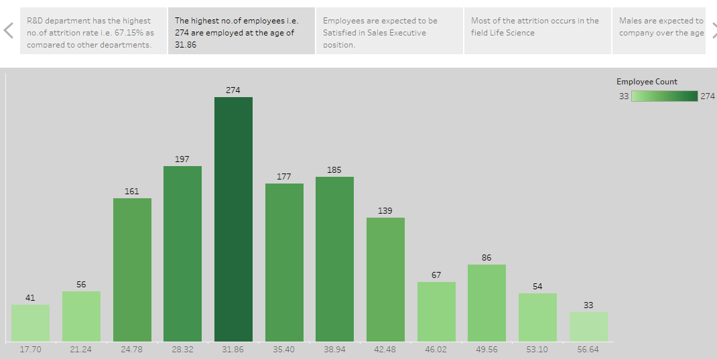

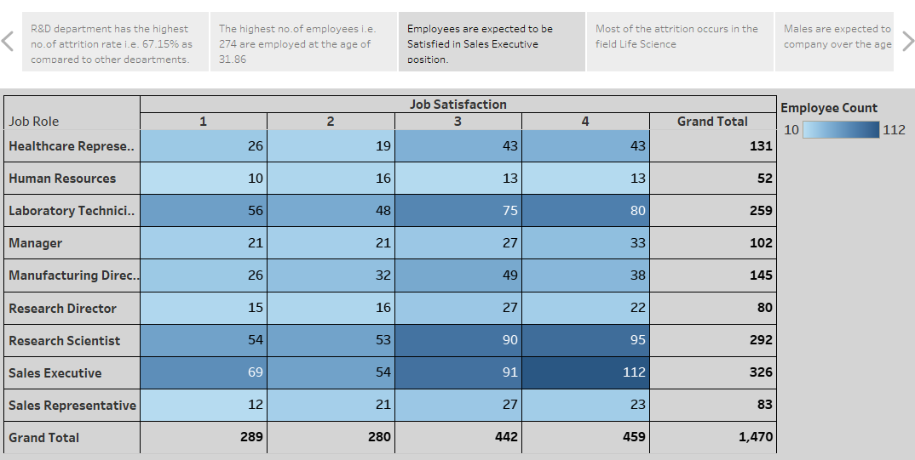

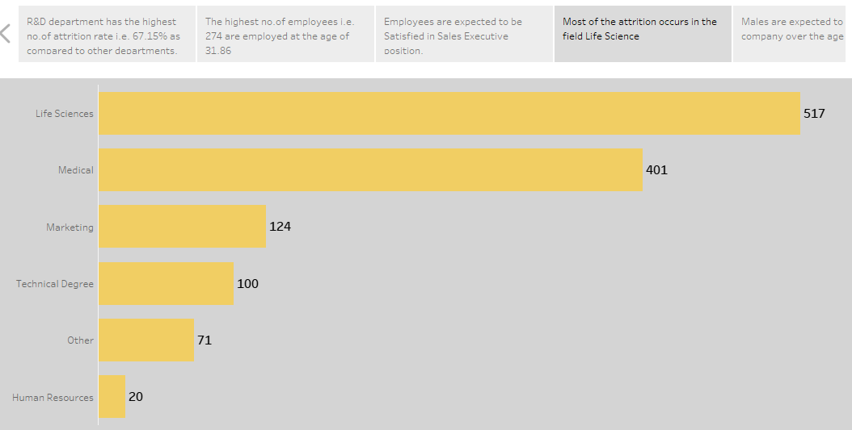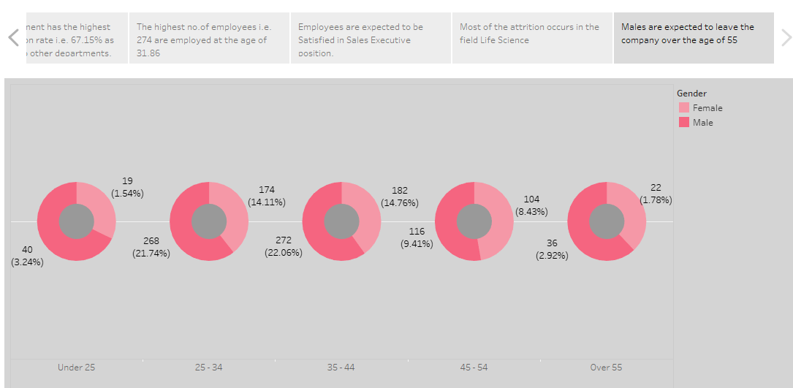

4 ADVANTAGES & DIADVANTAGES

Advantages:

Brings structure to business strategy

Makes communication Faster

Facilities better alignment

Connects the individual worker to organizational goals

Disadvantages:

It must be tailored to the organization.

It needs buy in form leadership to be successful.

It can get complicated

5 APPLICATION :

HR Planning can help business develop effective talent management strategies

Talent management is a distinct function of human resource development

It need buy in from leadership to be successful

If an idea spawns other ideas, link them together

Using lines and circles/shapes to form a cluster of ideas

6 CONCLUSION:

HR Scorecard is a report that you conduct to calculate the success rate of human resource employees and the overall department

Tableau is a powerful data visualization tool that can help business make better – informed decisions.

By collecting and analyzing data related to the people in an organization, HR analytics can help make data-driven decisions , measure the impact of HR initiatives , and shape the future of work.

7 FUTURE SCOPE:

Graduates of HR Analytics courses are well-positioned to work in a range of industries , including healthcare , finance , technology , and manufacturing.

Real time data visualization allows use to see data as it is being generated , providing instant insights and enabling quick decision-making.

The potential of Tableau is expanding as businesses become more dependent on data data-driven decisions.

8 APPENDIX:

<https://drive.google.com/file/d/1TQLqiUgSthNTeM2> XRCqAwbrGChk-M5I/view?usp=sharing

page break

APPLICATION: